Experiment : 3

* Insert a Document

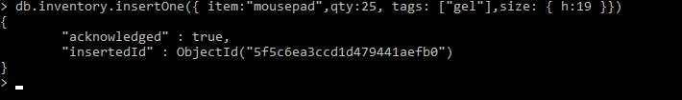

2.Save a Document

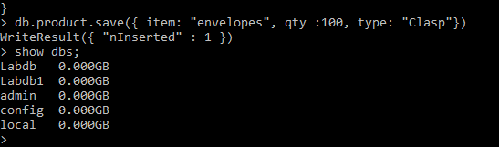

4.display collecton records

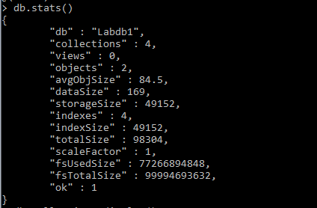

5.drop function

